NASA EVA

Gamification

P R O J E C T M A N A G E M E N T P L A N

**PHASE II**



**Prepared by**

Laura Addiego

Samia Alam

Kelli Corey

Charles Milk

Adeola Odusola

Hung Pham

**Table of Contents**

Revision Table 3

Background 4

Project Management Approach - Roles 4

Project Scope 5

Purpose and Justification 5

Scope Description 5

High Level Project Requirements 5

Project Boundaries 6

Project Strategy 6

Project Deliverables 6

Acceptance Criteria 6

Project Constraints 6

Project Assumptions 7

Milestone List 7

Milestone 1 7

Milestone 2 7

Milestone 3 7

Milestone 4 - Closing 8

Change Management Plan 9

Communications Management Plan 10

Purpose 10

Communication Channels 10

Among Team Members 10

With Stakeholders 10

Distribution of Information 11

Project Scope Management Plan 11

Schedule Management Plan 11

Timeline 12

Quality Management Plan 12

Risk Management Plan 12

Staffing Management Plan 13

Resource Calendar 14

Quality Baseline 14

# 

# Revision Table

|  |  |  |  |
| --- | --- | --- | --- |
| **Version #** | **Change Description** | **Author** | **Date** |
| 1.0 | Initial Release |  | 6/10/2018 |
| 1.1 | Updated Project Management Approach  Updated Milestones | Kelli Corey | 6/27/2018 |
|  |  |  |  |

# Background

NASA EVA Wiki is used to support the Extravehicular Activity (EVA) group’s knowledge management processes. It is a private wiki which is used to support various operations at NASA International Space Station. The ultimate goal of the project is to gamify the NASA EVA MediaWiki. Gamification is the process of integrating gaming mechanics into existing product or process to increase user participation and engagement. Gamification would increase the effectiveness of NASA wiki usage by applying motivational techniques which make users engaged and encouraged to learn or use the product more.

Phase one of the project which included user profile creation, email verification, and database setup work has already been completed. Phase one mainly created a foundation that can be built upon by the following phases.

Phase two is the continuation of the NASA wiki gamification project after the successful completion of phase one. Phase two will focus on adding different elements of gamification to the existing product. The elements will include adding different personality types, simple point system, badges, and adding a leaderboard. The project will continue to be open source to allow further development through different phases in the future.

# Project Management Approach - Roles

The project will be completed using a version of the Waterfall methodology. The project has been broken down into four phases; Requirements, Design, Coding, and Testing. Each team member has a leadership role for one aspect of the project. All team members will assist with the completion of tasks within each phase.

The Customer Management Lead, Charles Milk, is responsible for managing communication with the project stakeholders, stakeholder analysis, and analysis of business requirements.

The Development Lead, Hung Pham, is responsible for managing the implementation of the project per the agreed-upon design and ensuring that all requirements are met.

The Quality Assurance Lead, Samia Alam, is responsible for managing the verification and validation process, including development of the testing plan, creation of unit and system tests, and completion of testing.

The Database Lead, Laura Addiego, is responsible for managing the database design and implementation process, including database modeling and design.

The Documentation Lead, Adeola Odusola, is responsible for managing the project documentation, including creation of handover documentation.

The Project Management Lead, Kelli Corey, is responsible for management of project planning, scheduling, and deliverables.

# Project Scope

## Purpose and Justification

The main purpose of phase two of the project is to build an extension that will enhance the gamification of the NASA EVA wiki project to improve user activity. The primary users of this wiki are the astronaut instructors, the flight controllers who serve in MCC Houston, and the astronauts themselves but not limited to safety reps, people in the program office, engineers and designers, payload owners, hardware processing experts, and all the accountants that keep ISS operations in line. The benefit of this extension is expected to increase the overall number of above users viewing and contributing to the NASA EVA wiki that will help to solve knowledge management in ISS operations at NASA.

## Scope Description

The scope of phase two project is the continuation of the work on the wiki project from the previous team. The primary focus of this phase is to build an extension that provides a consolidated infrastructure allowing for adding different elements and approaches to gamification. Through this single extension, many different personality types could be addressed with a unified system. It will include simple point measurement, badge rewards system, and leaderboard ranks system, but the system will be scalable to allow for other personality types like socialites and explorers.

## High Level Project Requirements

The following key high-level project requirements are set for this phase project, but not limited to any continuation of the work on this wiki project.

* All code should be open sourced at the end of the project.
* All back-end code should be written in PHP.
* Front-end code may be written in JavaScript, JQuery, and CSS.
* A relational database such as MySQL, MariaDB, PostgreSQL, SQLite and others should be supported.
* All code should be stored in GITHub.

## Project Boundaries

The following key project boundaries are set for this phase project.

* This extension will use EVA Wiki in its scope only. All other wikis using MediaWiki are out of scope.
* This project is limited to supporting users in ISS operations community only. All other users are out of scope.
* This project covers any requirements that are defined in Project Scope section only. All other requirements are out of scope.
* This project will focus on user activities only. The content of the NASA MediaWiki is not included in the scope of this project.
* This project will be tested on development environment only. The production implementation is out of scope.

## Project Strategy

The NASA EVA Wiki project is divided into 4 milestone deadlines with each milestone consisting of several activities, supported with documentation, that must be completed. Each project activity will have a leader who is responsible for coordination. However, each activity will be divided into sections, which will subsequently be completed by members of the team.

## Project Deliverables

Project deliverables include:

* Documentation
  + MediaWiki Installation
  + Extensions
  + Future recommendations
* Source code and its documentation made available on GitHub.
* Handover documents

## Acceptance Criteria

* Documentation must be clear and concise.
* Source code must be fully tested and working through localized wiki setup with test data by team members.
* Codes and functionalities must fulfill design requirements.
* The handover documents must be submitted on time to meet the project deadline according to the project schedule document.

## Project Constraints

* The project is bound to the requirement specifications highlighted under the project scope.
* The project must be executed within the timeframe under the project schedule.
* The actual NASA wiki is not available to the team due to firewalls and access-control mechanisms in place for security purposes. Consequently, the team has to download and install a local version in order to test.

## Project Assumptions

* The project is a phase 2 project that depends on information from the previous phase 1 project and as such assumes that the information from the previous phase, in terms of code and documentation, are complete, tested, and working.
* The project will be focused on user activity as opposed to Wiki content.
* The potential users of the application are:
  + Instructors of Astronauts
  + Flight controllers
  + Astronauts

# Milestone List

Major milestones for the project are listed below, with deliverables. Further detail can be seen in the project schedule. Milestone dates are defined per the course schedule, and the end of Waterfall phases may not align with milestone dates.

## Milestone 1

Start Date: May 21, 2018

Completion Date: June 10, 2018

Deliverables: Project Charter, Project Management Plan, Stakeholder Analysis, Project Health, Project Schedule, Presentation to Stakeholders

## Milestone 2

Start Date: June 11, 2018

Completion Date: July 1, 2018

Deliverables: Completed requirements and updated project documents. Draft of database design, test plan.

## Milestone 3

Start Date: July 2, 2018

Completion Date: July 22, 2018

Deliverables: Completed database design, game design, and test plan. Updated project documents. Draft of project code.

## Milestone 4 - Closing

Start Date: July 23, 2018

Completion Date: August 12, 2018

Deliverables: Completed Project Code, Final Testing Results, Handover Documentation, and Presentation to Stakeholders

# Change Management Plan

While changes on this project are unexpected, should they occur, the following Change Management process will be implemented:

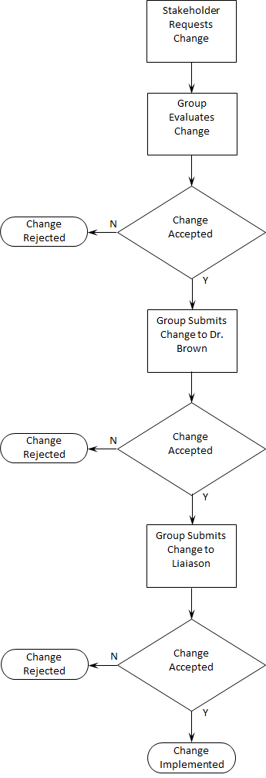

# 

# Communications Management Plan

# 

## Purpose

To create an effective way to communicate among team members and between the team and project stakeholders.

## Communication Channels

### Among Team Members

For internal communication, team members have agreed to interact using different channels: instant messaging, email, phone, cloud-based document sharing, and video conferencing. Each of which will satisfy a different purpose. From an organization perspective, the communication among team members will be horizontal.

|  |  |  |  |  |  |
| --- | --- | --- | --- | --- | --- |
| Channel | Tool | Description/Purpose | Formality | Type | Frequency |
| Instant Messaging | Slack | For quick communication and general purposes | Informal | Written | As needed |
| Email | Personal email | To distribute weekly meeting invitation | Informal | Written | Weekly |
| Phone | Personal phone | For emergencies | Informal | Oral | As needed |
| Video Conferencing | Zoom | For weekly meetings and screen sharing | Informal | Face-to-face | Weekly |
| Cloud-based Document Sharing | Google Drive | For online document sharing and team collaboration | Informal | Written | As needed |

During the project, the day prior to the team’s weekly meeting, the Project Management Lead will prepare and share the agenda with the talking points to be discussed during the meeting. Team members may add and update items to the agenda if needed.

### With Stakeholders

The only channel that will be used to communicate with stakeholders will be email, and the format that will be used is formal. Dr. Brown will communicate with the team and the team leader with him via email as needed.

## Distribution of Information

|  |  |  |  |  |  |
| --- | --- | --- | --- | --- | --- |
| Vehicle | Target | Description/  Purpose | Owner | Distribution  Vehicle | Frequency |
| Status Report | Professor | To communicate project progress and to provide deliverables | Project Lead | Written | Every 4 weeks (at the end of each Milestone) |
| Presentation | Professor | Present project progress and deliverables status | Project Lead | Written | Twice along the project: at week 3 and week 12 |
| Presentation | EVA Instructor & Flight Controller | Present project progress and deliverables status | Project Lead | Written | Every 4 weeks |

# Project Scope Management Plan

The project scope management plan is listed as below.

* The project scope has been defined in Project Scope section.
* The project team will work together to create the Work Breakdown Structure (WBS).
* The project sponsors and stakeholders will review the WBS to ensure all requirement are covered and accurate.
* The project team will determine the tasks required to accomplish each deliverable.
* All requirements that are defined in Project Scope section will be validated and controlled to ensure that they are in scope.
* The project sponsors and stakeholders will verify the completion of project deliverable.

# Schedule Management Plan

Microsoft Project 2016 will be used as the tool to develop the Schedule Management Plan. This will list the project’s milestones, activities, and tasks necessary to accomplish those goals. Additionally, it will include the criteria for monitoring and controlling tasks, resources, time allocations, logical relationships, and dependencies among tasks. The critical path of the project will be generated by the tool and used to associate Milestones to dates.

A project schedule baseline will be set as the guidance for controlling that the project stays on track and meet the established deadlines. Since this project is constrained by the start and end dates of the class, the project’s end date cannot be altered. Therefore, as we move along on the project’s timeline, the scope might be adjusted to satisfy the time restriction.

## Timeline

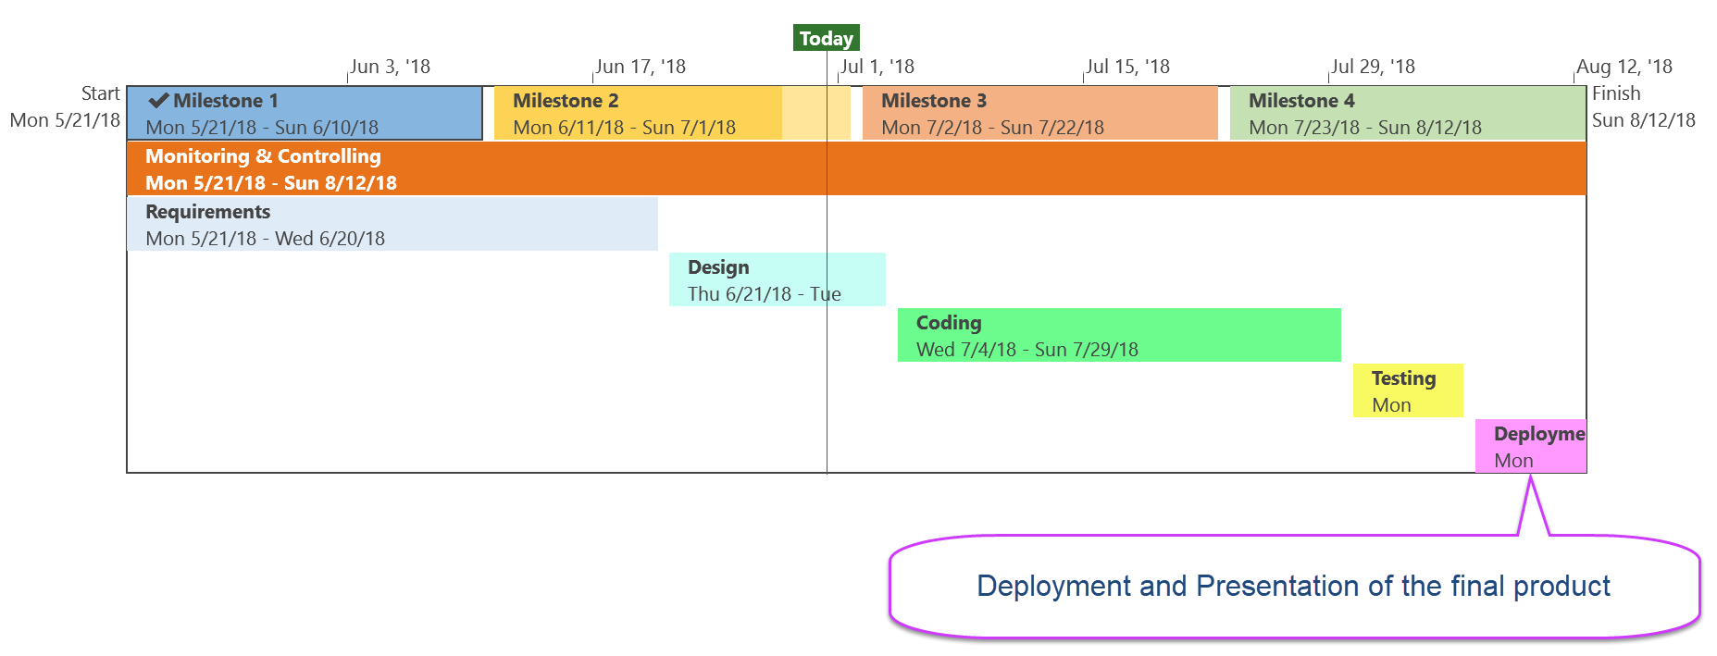

# Quality Management Plan

The primary purpose of Quality management Plan is to define how quality should be assessed and managed throughout the software development lifecycle. Each member of the team will be responsible to ensure high quality of all documentations, codes, and test scripts.

All team members will review and approve all deliverables prior to submission. For coding portions of the project, PHP and MediaWiki conventions will be followed. At periodic intervals during the development cycle, the team will review all deliverables for clarity, consistency and accuracy. This review may be performed by the team as a whole or separately by individual members.

When an issue is identified, consistent actions will be taken to address the issue. If issues are found by an individual reviewer, he/she will inform the rest of the group and provide suggested corrections. The group will then determine the proper course of action. Any design changes made to resolve an issue will be documented for future references. Similar processes will be followed for documentation and test script review.

# Risk Management Plan

During the Planning phase of the project, the team will identify potential risks and write contingency plans applicable to each. This plan will be included with the design documentation and approved by all members of the team. This plan will also incorporate risks identified by the Phase 1 team; if necessary, the plan to address those risks will be updated.

If new risks are identified during the project, then the identifying team member will notify the group. The team will determine how to address the risk, and the risk management documentation will be updated appropriately.

Risks will be assessed using a probability and impact matrix. Risks with the highest probability and potential impact will be prioritized to be addressed. The probability and impact matrix to be used is shown below.

|  |  |  |  |  |  |  |
| --- | --- | --- | --- | --- | --- | --- |
| Probability | Very Likely |  |  |  |  |  |
| Likely |  |  |  |  |  |
| Moderate |  |  |  |  |  |
| Unlikely |  |  |  |  |  |
| Rare |  |  |  |  |  |
|  | | Low | Minor | Moderate | Major | Extreme |
| Impact | | | | |

The handover documentation will include risks identified in both Phase 1 and Phase 2 of the project, as well as the solutions developed to address them.

# Staffing Management Plan

The members of the team were assigned by Dr. Brown for the SWEN 670 course, and the team assignments cannot be changed. A new team will be assigned for the Fall 2018 semester to take over project development.

# Resource Calendar

All members of the team will be needed for the entire length of the project, which will last for the duration of the Summer 2018 semester. Team members will be working during time that they have available, including nights and weekends. All team members are expected to contribute to all phases of the project.

# Quality Baseline

The purpose of quality baseline is to ensure that:

1. The codes meet requirement specifications;
2. The code and functionality will be tested and validated;
3. Any changes to the initial module design will be documented;
4. Functionality of the product will be documented; and
5. Tools and techniques used to develop and validate the product will be identified and managed.

The following baseline standards must be met in order to consider the project to be successful:

|  |  |  |
| --- | --- | --- |
| **Areas** | **Acceptable Standard** | **Comment** |
| Product Modules | The modules fulfill all the requirements mentioned in the software requirement specification document. |  |
| Code | Codes fulfill all requirement specifications. |  |
| Database | A SQL script is created and run without error to update the current database with desired features. |  |
| Quality Assurance | Unit tests are created to ensure 100% code coverage and adequate data coverage. |  |
| Documentation Management | All changes in the product design are documented. Functionality of all new features are documented. |  |